Running SolidPython from FreeCAD
Prerequisites:
FreeCAD, OpenSCAD and SolidPython must be installed on the computer.
SolidPython is available here: https://github.com/SolidCode/SolidPython

A first test:
- Enable the report panel: Menu View – Panels - Report
- Create new macro and enter SolidPython code e.g.
from solid import *
from solid.utils import *
d=cube(10) – up(5)(right(15)(sphere(12)))
print (scad_render(d))
Now the OpenSCAD source code is displayed in the report panel:
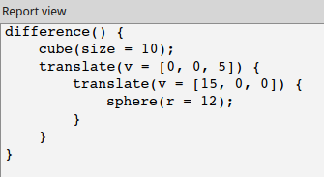
Copy it.
- Open the OpenSCAD window: Menu OpenSCAD – Add OpenSCAD element
Paste the openSCAD code to the window that opens (eventually clear existing code before pasting):
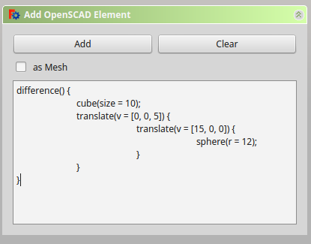

Now the result is visible in the object tree and in as a drawing:
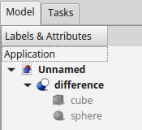
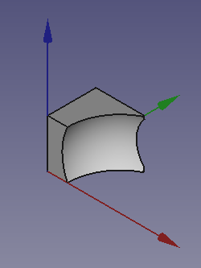

Automatic rendering of the drawing
When I began to experiment with SolidPython, I found the described proceedure a little bit clumsy.
Wouldn't it be possible to automate the process, so that it would be enough to write the code and let FreeCAD do the rest? Surely this must be possible, due to FreeCAD's excellent Python scripting possibilities!
So I had a look into the source code of the OpenSCAD workbench of FreeCAD.
For each button there is a class, in our case AddOpenSCADElement:
class AddOpenSCADElement:
...
def Activated(self):
panel = AddSCADTask()
FreeCADGui.Control.showDialog(panel)
....

The interesting class is AddSCADTask, and here the method addelement:
class AddSCADTask:
...

def addelement(self):
scadstr=unicode(self.form.textEdit.toPlainText()).encode('utf8')
asmesh=self.form.checkboxmesh.checkState()
import OpenSCADUtils, os
extension= 'stl' if asmesh else 'csg'
try:
tmpfilename=OpenSCADUtils.callopenscadstring(scadstr,extension)
doc=FreeCAD.activeDocument() or FreeCAD.newDocument()
if asmesh:
import Mesh
Mesh.insert(tmpfilename,doc.Name)
else:
import importCSG
importCSG.insert(tmpfilename,doc.Name)
try:
os.unlink(tmpfilename)
except OSError:
pass
...

Not all of this is necessary for our task.
The essential lines are
tmpfilename=OpenSCADUtils.callopenscadstring(scadstr,'csg')
doc=FreeCAD.activeDocument() or FreeCAD.newDocument()
importCSG.insert(tmpfilename,doc.Name)
where scadstr is the string with the OpenSCAD commands that is generated from SolidPython.

To test this, I wrote a small macro and started it from FreeCAD:
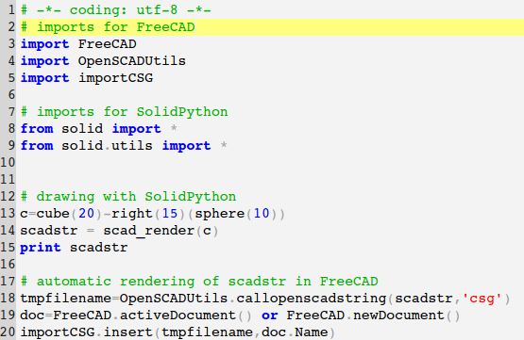
This threw some error messages, but the drawing was automatically generated, as expected:
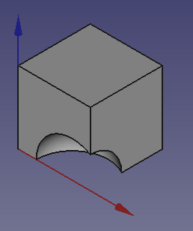
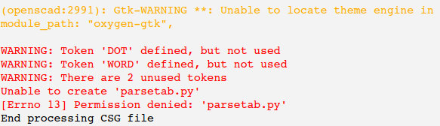

By the way, the parsetab.py error showed also with the other method

