From draft to G code
Workflow for FreeCAD 0.17 by jean-claude.feltes@education.lu
Example: front plate

Draft
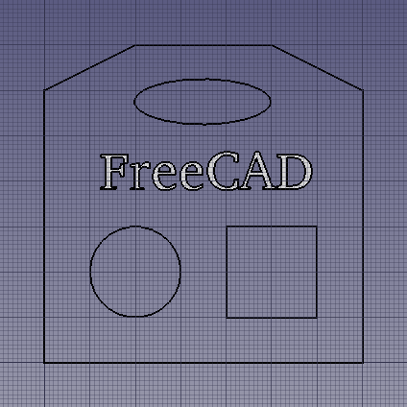
Test drawing:

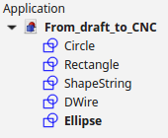

(How to work with Draft: Tutorial: http://www.freecadweb.org/wiki/index.php?title=Draft_tutorial )

Creating the paths
General configuration
- Switch to Path workbench
-  Create a new path object
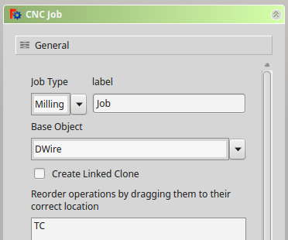

- Set base object to the object that represents the outer boundaries (in our case a Dwire).
This will be used for the outer contour path.
I had a problem with this in v 0.179088. The contour path could not be created. The problem was solved by upgrading the Dwire to a face.
-  Edit tool table
Create new tool e.g. 2mm end mill and add it to the job (with the blue arrow button in the middle)
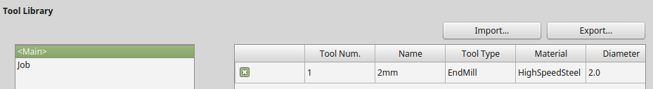
Now the new tool appears in the tree view.
- In the tool properties box, set spindle speed and feed rates
Take care: in v 0.179088 the feed rates have a unit mm/s in the GUI window. The post processing script ignores these units, so if you enter 200mm/s for example, this is translated to F200 in the G code. My LinuxCNC would interprete this as 200mm/min, and not as 200mm/s. So just ignore the mm/s.
Contour path
-  Create contour path for the base object.
This does a contour path for the outer boundaries of the object.
Set depths and safe heights
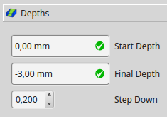 | 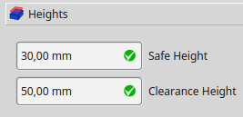

If this doesn't work and the outer boundary is a Dwire, try to upgrade it to a face ( do this in in the Draft worbench)
The path can be verified in the orthographic view:
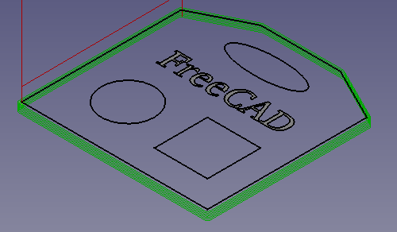

Path for the rectangular, circular and elliptical holes
- Profile based on edges
This does the path for any holes in the plate.
Select „Base Geometry“
In the drawing, select the desired elements (<Ctrl><LKlick>) and press the „add“ button.
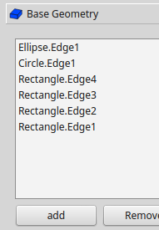
Set Depths and Heights as you have done for the contour path.
In the Operation tag, set Direction (CW/CCW) and Cut Side (On, Right, Left)
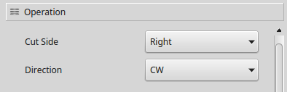
For Right and CW, the cut is on the inner side of the selected objects.
Now we see the new paths in the orthografic view:

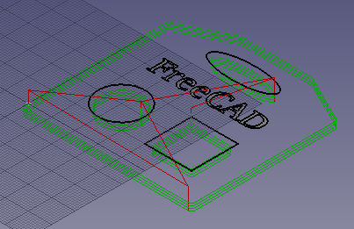

Engraving
Select „Base Geometry“
In the drawing, select the text to engrave and press the „add“ button.
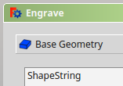
Set the depth of the engraving, (and eventually the safe heights):
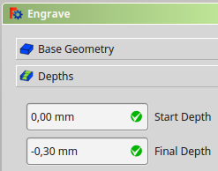
Now we see all paths in the tree view, and in the orthographic view of the drawing
(to better see (or even to see at all ) the engraving path, it is a good idea to turn off the visibility of the ShapeString (in the tree view, select and press <Space>).:
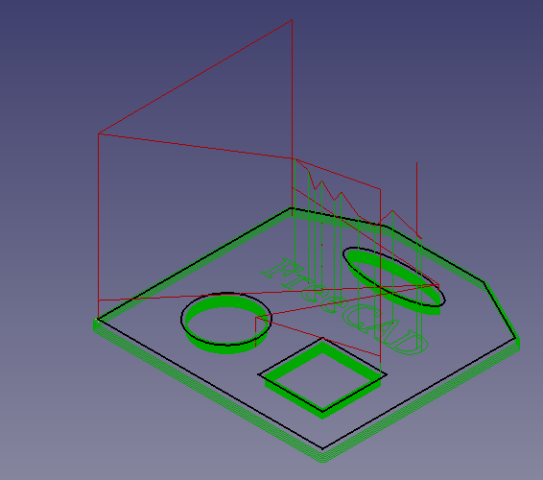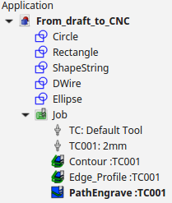

Postprocessing the paths
This creates the G code.
It is a good idea to produce 3 different files for contour, profile and engraving.
In the tree view, select the paths and press the postprocessing button. Save the resulting files. The result is displayed in a text box:
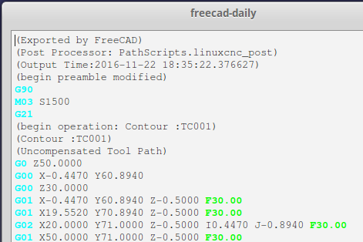
Note:
I have slightly adapted the postprocessor script for LinuxCNC, so as to switch on the spindle at the beginning and switch it off at the end. This is done in the PREAMBLE and POSTAMBLE variables. To do this, I have a copy of /usr/lib/freecad-daily/Mod/Path in the folder ~/ .FreeCAD/Mod/Path that I can modify without changing the original. FreeCAD always looks looks in the home folder first. The script to edit is linuxcnc_post.py in the PathScript folder. According to experts, this should also work if the modified linuxcnc_post.py file alone is put into the macro folder.

