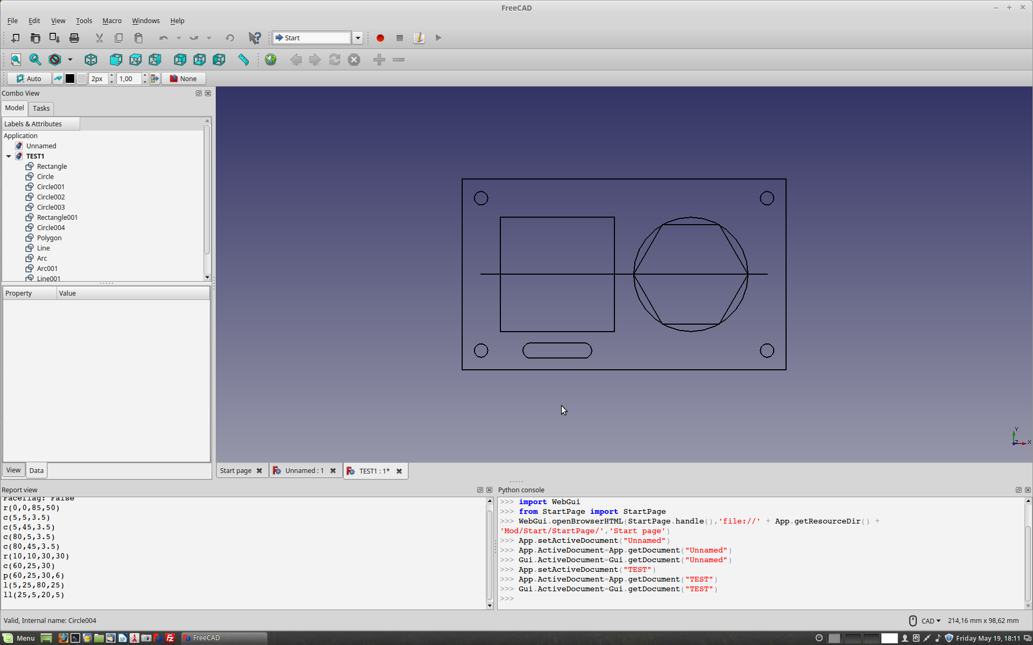
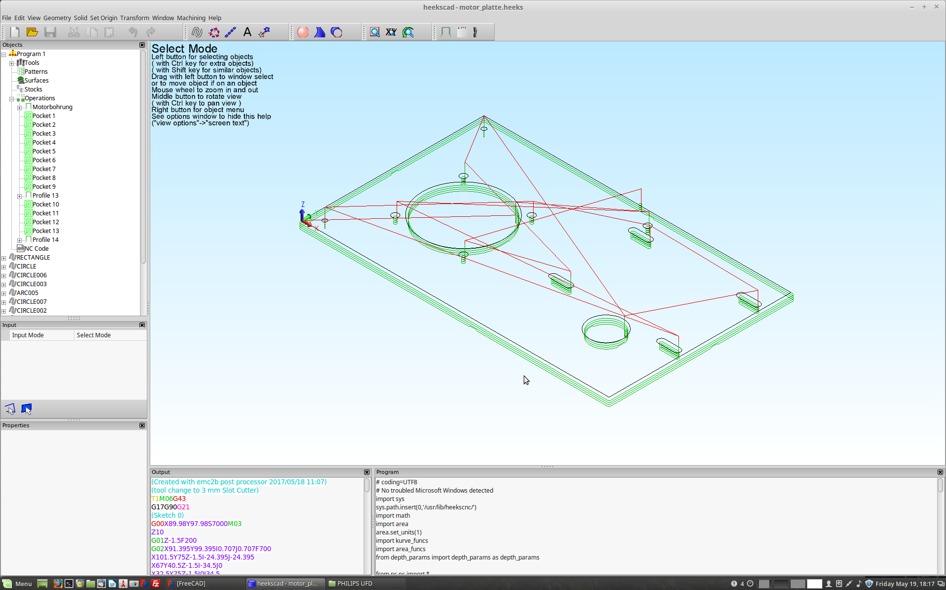
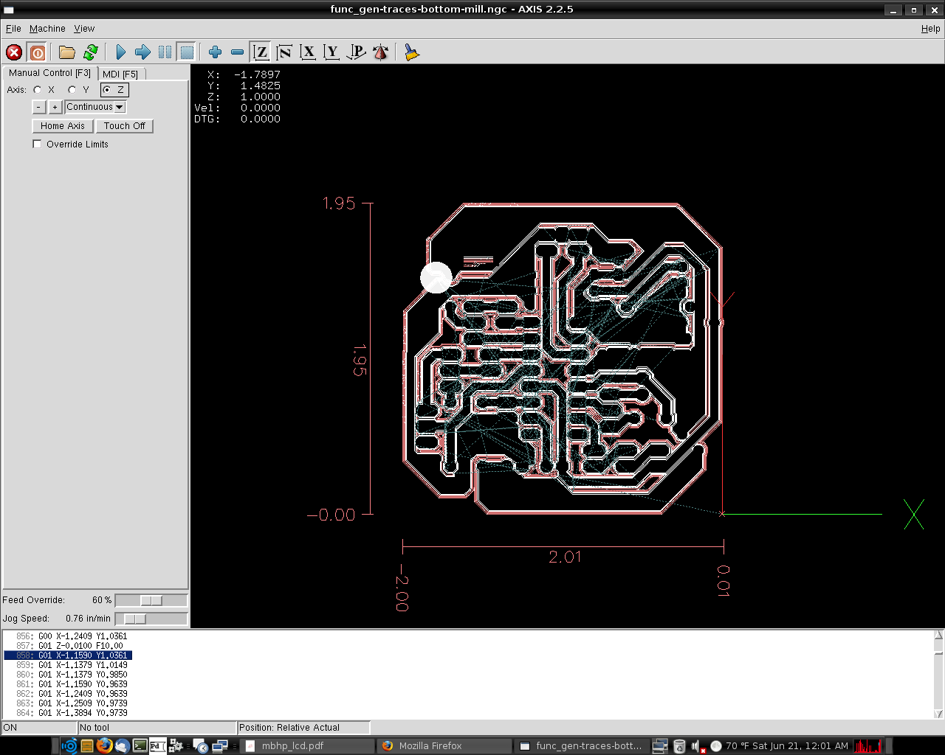
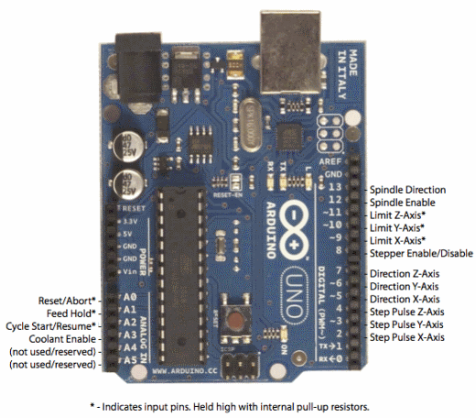
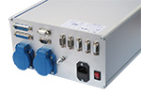
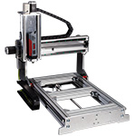
CAD
CAM
Gcode
interpreter
Motor
driver
Step motors
(mill, lathe...)
HeeksCNC
FreeCAD (*)

FreeCAD
LibreCAD
HeeksCAD

LinuxCNC = Emc2
or
GRBL Arduino board

(*) FreeCAD CAM is currently being developed, will probably be very performant when ready
HeeksCNC is working fine, but development is stagnating (state 5.2017)

SOFTWARE:

CAD | FreeCAD  LibreCAD  HeeksCAD  Inkscape | 2D, 3D, Free, Open Source  Free, Open Source  2D, 3D, Free for Linux, Open source | https://freecadweb.org/  http://librecad.org/cms/home.html  https://sites.google.com/site/heekscad/home
CAM  PCB CAM | FreeCAD Path module  HeeksCAD / HeeksCNC  BlenderCAM  dxf2gcode  pyCAM  CAMBAM  CAMmill  pcb2gcode  FlatCAM | (under development!)  included in HeeksCAD  can be integrated in LinuxCNC  (sleeping??)  (free up to 1000 lines G code)  not really documented  converts gerber files to gcode  converts gerber files to gcode | https://freecadweb.org/  https://sites.google.com/site/heekscad/home  http://blendercam.blogspot.lu/  https://sourceforge.net/projects/dxf2gcode/  http://pycam.sourceforge.net/  http://cambam.info/  https://sourceforge.net/projects/pcb2gcode/  http://flatcam.org/
CAM  Simulation | CAMotics | Allows simulation of what the Gcode does  Info about other simulators: | http://www.camotics.org/  https://www.shapeoko.com/wiki/index.php/Previewing_G-Code
G code interpreter | LinuxCNC  GRBL - Arduino | Real time operating system for CNC (on PC)  Arduino with GRBL Firmware | http://linuxcnc.org/  https://github.com/grbl/grbl/wiki

My favorites are marked in bold.
All the software listed is free and Open Source and available for Linux

CAD

FreeCAD
Is for 2D and 3D drawing, is under heavy development and very promising. There are a lot of good tutorials to be found.
FreeCAD is very modular, it has an App and a GUI part. Both are written in C++, but have a Python interface. Extension modules for all kinds of purposes can be written in Python. So freeCAD is very future-oriented and very OPEN!
FreeCAD has a lot of different „Workbenches“. Each of these is suited for a special task. You can write your own workbench if you want.

HeeksCAD
Is for 2D and 3D drawing. Includes HeeksCNC that allows Gcode generation.

Inkscape
is for 2D drawing. Includes generating Gcode for laser cutting, but with no tool path compensation

CAM

HeeksCAD / HeeksCNC
generates G code. Profile operations include generation of holding tags to prevent pieces of material to get loose and fly around.
Documentation OK.
Development seems to sleep for the moment, but HeeksCNC is functional.
Post processor files can be extended by Python scripts.
HeeksCAD generates a master Python script that generates the g code and that can be edited and reloaded. Maybe this can be combined with FreeCAD?

CAM for engraving printed circuit boards (PCBs)

pcb2gcode
is a command line tool that converts Gerber files (produced by EAGLE or KiCAD or any pcb program) to Gcode.

FlatCAM
Seems well documented and easy to use. Written in Python. I have not tested it yet.
Installation:
download zip file, extract, open terminal in folder, sudo bash setup_ubuntu.sh to install dependencies, start FlatCAM with python flatcam.py

CAM simulation

CAMotics

Gcode interpreters

LinuxCNC (Emc2)
is a real time operating system especially designed for controlling step motors and servo motors
Advantages:
- displays a simulation of the tool path and displays coordinates
- can drive up to 9 axes
- contains kinematic modules for coordinate transformation
- can generate high pulse rates
- has a hardware abstraction layer (HAL) that allows generating and analysing signals
- GUI can be chosen between several variants, and may be extended in Python
Disadvantages:
- Needs a PC with parallel interface for communication with the motor driver

Arduino with GRBL firmware
Gcode is sent to Arduino via USB
Arduino decodes it and generates the control signals
Advantages:
  - does not need a PC to run, no boot delay, small and cheap
Disadvantages:
- no display of the toolpath as there is only a small LCD display, if any
- number of axes is limited (t
- some Gcodes are still missing (probably not very important ?)

MaxiPosi board with GRBL
is a very promising board developed by „Make“ that is Arduino compatible and has a lot of features specially designed for CNC use

