Arduino notes 2: Serial communication
This is not a tutorial, but a collection of personal notes to remember the essentials of Arduino programming.
The program fragments are snippets that represent the essential pieces of code, in an example.
jean-claude.feltes@education.lu

Arduino web site:
http://arduino.cc

Serial:
https://www.arduino.cc/reference/en/language/functions/communication/serial/

Good examples and summary on the commands:
http://forum.arduino.cc/index.php?topic=396450.0

Receive a character via Serial
This lets the Arduino react to serial input.
The following example switches a LED on or off with the characters '1' and '0':
int led = 13;

void setup() {
pinMode(led, OUTPUT);
Serial.begin(115200);
}

void loop() {
if (Serial.available()){
char ch = Serial.read();
if (ch == '1')
digitalWrite(led, 1);

if (ch == '0')
digitalWrite(led,0);
}
}

Receive an integer number via Serial, explicit programming
To communicate with the controller, a number is sent, terminated by a newline character '\n'.
To test this program with the serial monitor, activate the newline option:
The example program waits for a number input, multiplies it by 2 (to do something with it) and sends it back:
void setup() {
Serial.begin(115200);
}

unsigned int mynumber=0; // Max value is 65535, use long for bigger numbers
char incomingByte;

void loop() {
if (Serial.available() > 0) {
mynumber = 0; // delete previous number

// read until 'n':
while(1) {
incomingByte = Serial.read();
if (incomingByte == '\n') break;
if (incomingByte == -1) continue;
mynumber *= 10;
mynumber = ((incomingByte - 48) + mynumber);
}
// Number received, now do something with it
Serial.println(mynumber * 2);
}
}

When a character is read, the previous number is first set to zero.
Then, as long as there is no newline character, bytes are received , converted from ASCII to integer (by substracting 48), and added to mynumber that is shifted one decimal place to the left (by multiplying with 10) before the addition.

For a better overview we can define a function readNumber():
This waits for a number to be input (ending with newline)
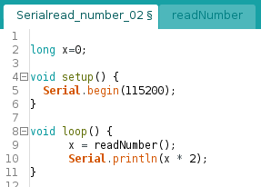
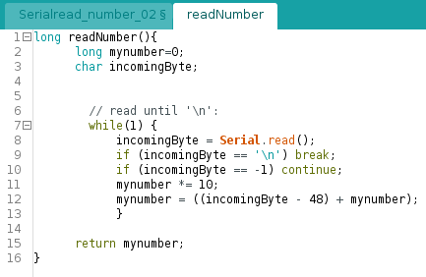

The disadvantage is that the program execution is blocked while it waits for input.

Receive a number via Serial, with parseInt / parseFloat
These functions provide a simple method of receiving:
long x=0;

void setup() {
Serial.begin(115200);
}

void loop() {
if (Serial.available()){
x=Serial.parseInt();

// do something with x
Serial.println(x * 2);
}
}

https://www.arduino.cc/reference/en/language/functions/communication/serial/parseint/
To receive a float number, use parseFloat()

http://forum.arduino.cc/index.php?topic=236162.0
http://forum.arduino.cc/index.php?topic=396450.0
http://forum.arduino.cc/index.php?topic=225329.msg1810764#msg1810764

Literature:
[1] Julien Bayle: C Programming for Arduino, Packt.
This is an excellent and very practical introduction

